Representations of Donkey’s

page2image27772608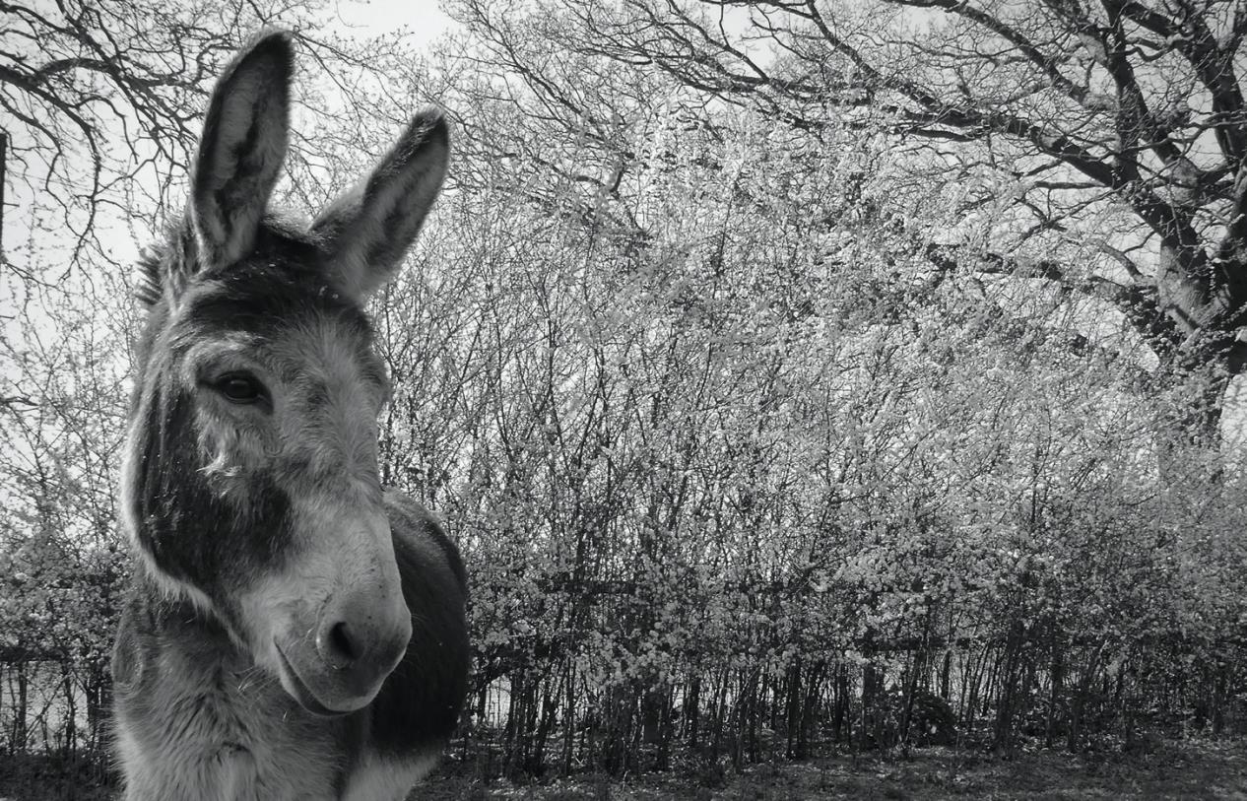

**Fig. 1*.*** *‘Bombonel’* (2017).

“Don’t waste your time young lady, she heard the farmer say

That donkey, well he’s stupid; they’re all just born that way

"He’s slow to move, can take no load in buggy or in sack,

The only thing he’s good for is a whip across his back" (Flicka Foundation).)

Throughout history donkeys have continually been depicted as stubborn ‘beasts’ and animals of the lower class and although often represented through children’s books and icons of religion as a messenger of peace and suffering (Bough, 2011) the donkey continues to be one of the most used, abused and neglected non-human animals on the planet. (Gorman, 2016).

In this essay I examine the roll of the donkey as represented in history through domestication, aesthetics, art, literature semiotics and performance. I have chosen this subject because I believe the ongoing welfare issues for donkeys relates to negative representations through media and language. I will be examining the comparisons used to demean their character, global problems for the donkey and how we could change our perceptions empathically.

Little is known of the domestication of the wild ass (see figure 2), but recent archaeological excavations have provided more information as to their status and history (Bough, 2011). Through findings such as the ten skeletons discovered symbolically buried facing Southeast besides the tomb of a first dynasty Egyptian King showing domestication to be at least 5000 years ago (Rossel *et al.*, 2008).

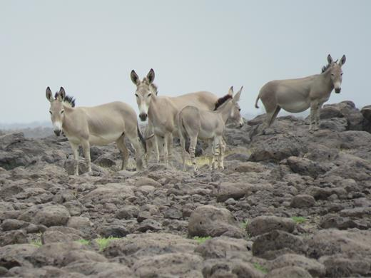

**Fig 2.** *African wild ass (Equus africanus) (Tesfai.R 2019)*

Assumptions that donkeys are creatures born for charity and peace is romanticised as the domesticated ass live to supply and toil for humans (Berger 1980).

Berger explains that it is the non-human animals silence and lack of human language that confirms its exclusion from man. Maybe through the transgression of souls after death, these lives may converge once more (Berger,1980). If the soul resides in forgiveness, generosity, courage and heroism then surely the donkey is a soul we should protect (Kowalski, 2007).

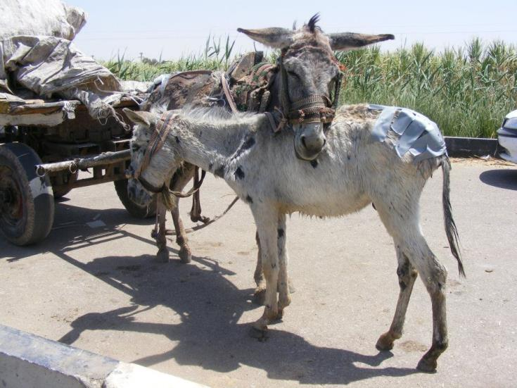

**Fig 8***. Working Donkeys. (2014)*

The ongoing devaluating representation of the donkey, along with continued rejection by the elite, confirmed their attachment to the poor and oppressed (Mitchell,2018. p230).

Rose says humans have a delusional ‘dead end’ attitude to saving other lives, as if we are so disconnected to each other that it is no longer our concern. But the certainty within that mindset is “our lives are held in the hand of others; without them there is no us” (Rose, 2011: 144).

References

Berger, J. (1980) *Why look at animals*, London, Penguin Books. pp10-13.

Bough, J. (2011) *Donkey*, London, Reaction Books.

Gorman, J. (2016) *Where’s the love for donkeys?* The New York Times Online. 1-4 Available at: https://nyt.ms/2e4fme.

Kowalski, G. (2007) *The soul of animals*, 2nd edition [e book] USA, New World Library. Available at: https://books.google.co.uk/books?id=JGZqOySw7QEC&printsec=frontcover&source=gbs_ge _summary_r&cad=0#v=onepage&q&f=false.

Mitchell, P. (2018) *The Donkey in human history: An archaeological perspective,* Oxford University Press.

Rose, D. (2011) *Wild dogs dreaming: Love and extinction*. USA, University of Virginia Press. Pp 144

Rossel, S., Marshall, F., Peters, J., Pilgram, T., Adams, M.D and O’Connor, D. (2008) *Domestication of the donkey: timing, processes and indicators.* PNAS. 105:10.3715-3720. Available at: https://www.pnas.org/content/pnas/105/10/3715.full.pdf.